### 4.2.2 Implementation Consulting

This chapter will analyze what needs to be done in future to use the learning factory in full extent. It will be shown which hardware needs to be acquired, and what software is missing.

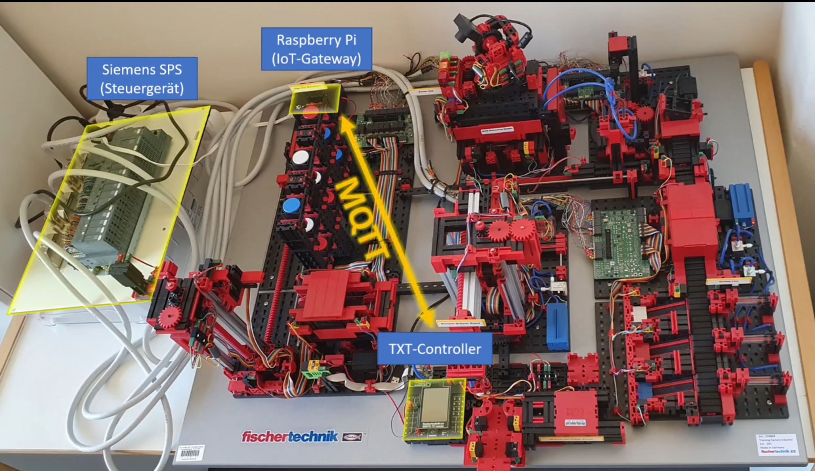

Siemens PLC

Figure 4.x: Controller Overview (Klein, M., <https://www.hs-albsig.de/studienangebot/wissenschaftliche-weiterbildung/osteraktion/osteraktion-12-lernfabrik/?sword_list%5B0%5D=lernfabrik&no_cache=1>)

The figure above shows the prototype of the factory. All the parts not highlighted can be found in the factory of the Innovation-Lab. The order elements are discussed in the following.

The purple highlighted parts are a combined sensor station. It is located on top of the oven, which is already part of the labor’s factory. The biggest sensor of the station is a camera. It is capable of 360° filming. This is used for a web based remote control. The camera is not integrated in the software that controls the factory. It is meant for enabling persons far away from the factory to take a look. Environment sensor make up the other sensors of the station. The built in sensors are for measuring:

* Brightness
* Temperature
* Humidity
* Air quality

These values of these sensors get collected and analyzed. They help to monitor the factory. With them, one can make sure that the production process is always within limits.

Highlighted by the green circle is the delivery station. The whole station is missing. It is used for incoming as well as outgoing goods. It consists of several elements. At the end of the production the gripper puts the workpiece into the delivery space. A light barrier is activated hereby. This information is collected by the controlling script. The information is then processed with all the other station data through the preparation steps to analyze it with the neuronal network. The missing information will be seen as an interruption to the production and a danger of a hang-up in the software.

In the following step the gripper puts the workpiece onto an color sensor. It detect the color of the product. The color information is also stored. As soon as the workpiece is back into the storage, the software knows which color it has. During ordering a customer can select the wished color. The software is able to get a matching product.

In the final step of the delivery station a NFC reader and writer tags the workpiece with the production information. This is important that the workpiece “knows” what it is. Thus this step is used as a simulation to real world factories, the NFC chip of the workpiece is not read again. Meaning it is a nice to have feature for the factory simulation, but not necessary for the neuronal network.

Attached to the delivery station is the Fischertechnik txt controller. Its purpose is to collect all sensor information. After the data collection it is send to the IoT-Gateway via MQTT standard. There is no specification which chip has been used. There is also no information about the used software. This makes it hardly possible to rebuild this element.

The IoT-Gateway receives the data from the txt controller. The hardware used is a Raspberry PI. It has two purposes. The first purpose is to control the ordering process. The software used for this is the python script that was introduced in the course. The second purpose is to transmit the factory data to the cloud. This is handled with the OPC UA protocol. In the cloud the source code for the neuronal network is running. So this connection is crucial to hand the production information to the neuronal network.